LECTURE 2



ELECTRIC FIELD

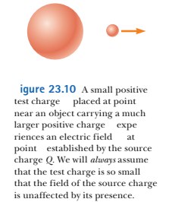Coulomb’s Law: $F=k\frac{Qq}{r^{2}}=k\frac{Q}{r^{2}}∙q=E∙q$

E is an electric field

E is an electric field exerted on a test charge, per unit charge

$$\vec{E} = \vec{F}/q$$

Electric field in SI system is measured in *newton/coulomb* units: N/C

Electric field is a fundamental concept – not limited by Coulomb’s Law

E field can be produced by a single charge, or by many charges, or by moving permanent magnet, or by light (light is an electromagnetic wave).

The test charge serves as a *detector* of the electric field: an electric field exists at a point if a test charge at that point experiences an electric force.

If an arbitrary charge *q* is placed in an electric field **E**, it experiences an electric force given by**: $\vec{F}=q\vec{E}$**

The direction of an electric field:



where **r**^ is a unit vector directed from *q* toward *q*0

The electric field is defined by: $\vec{E} = \vec{F}/q_{0}$,

hence



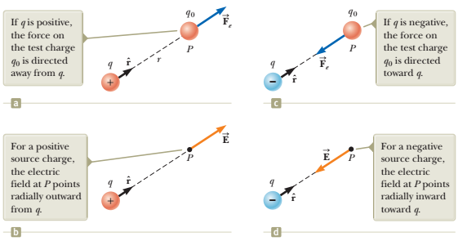

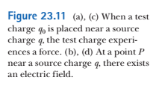

a distribution of charges: q1, q2, q3 …

we add qtest

Coulomb’s Law : $F=\sum{F_{i test}}=F_{1 test}+ F_{2 test}+…$

The electric field in the location of qtest: E = F/qtest



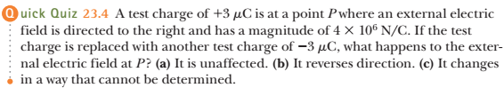

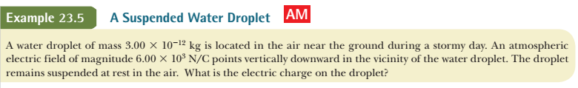

electric force: E*q (upward)

force of gravity: mg (downward)

balance condition: Eq = -mg

q = - mg/E =



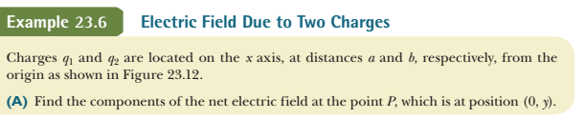

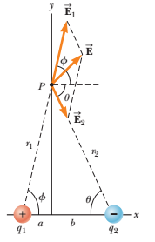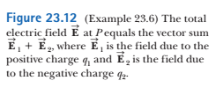

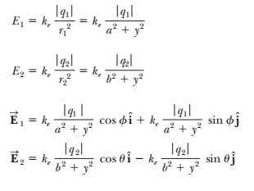



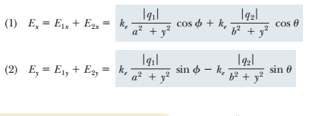



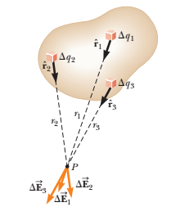 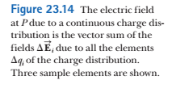

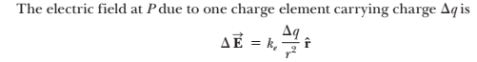

:



for continuous distribution of charge:



Nonuniform charge distributions:

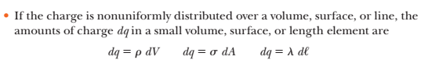**Volume charge density**:

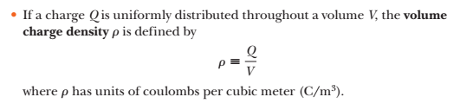

**Surface charge density**:

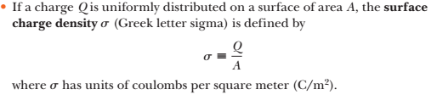

**Linear charge density:**

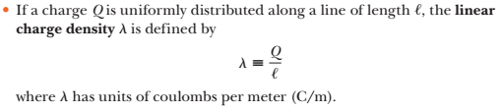

Examples:

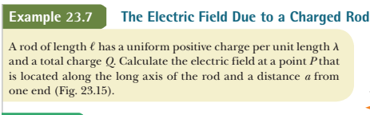

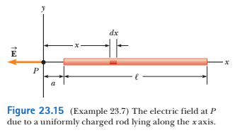

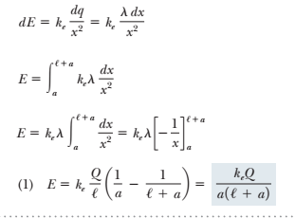



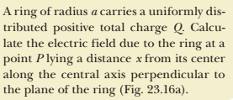

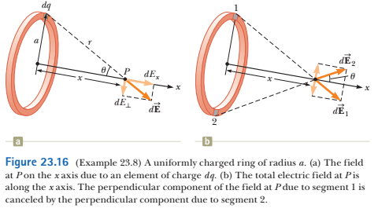

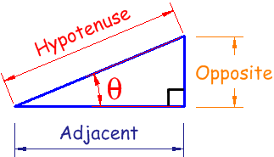

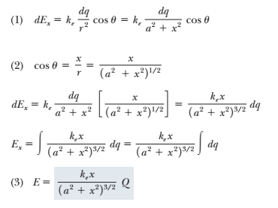

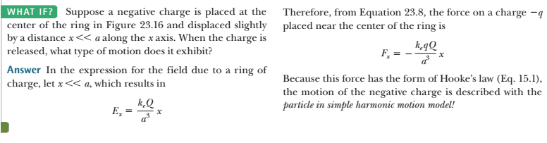

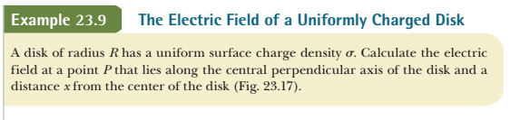

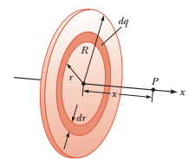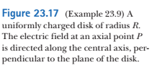

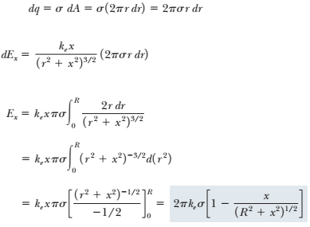

for x>> R: E = k Q/ x2

for x<<R:



for R -> infinity:

